## Question 1. Create a pipeline named 'GetMetaData_Example' to fetch the list of all the files available inside the ADLS folder.

Solution:-Firstly create a GetMetaData activity for check file exist condition and then if activity for check condition if file exist then copy the data.

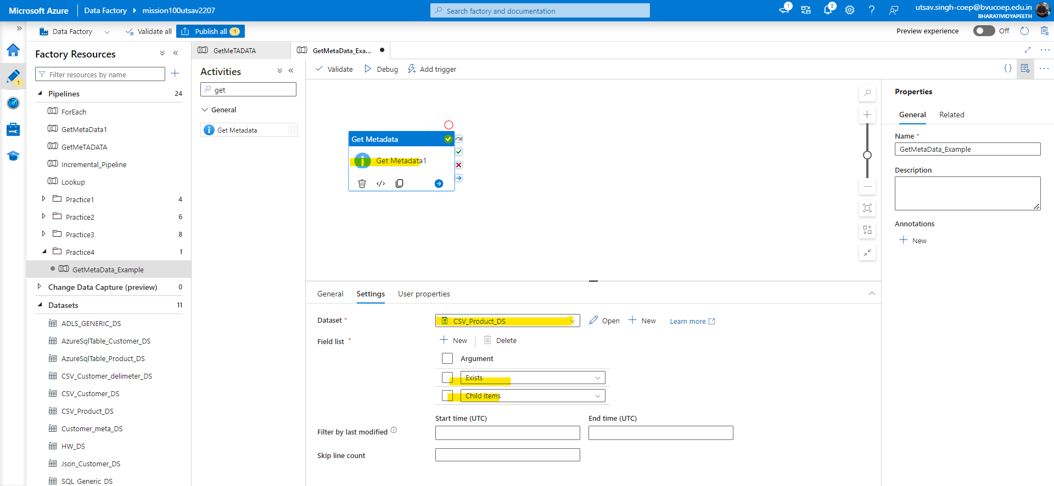

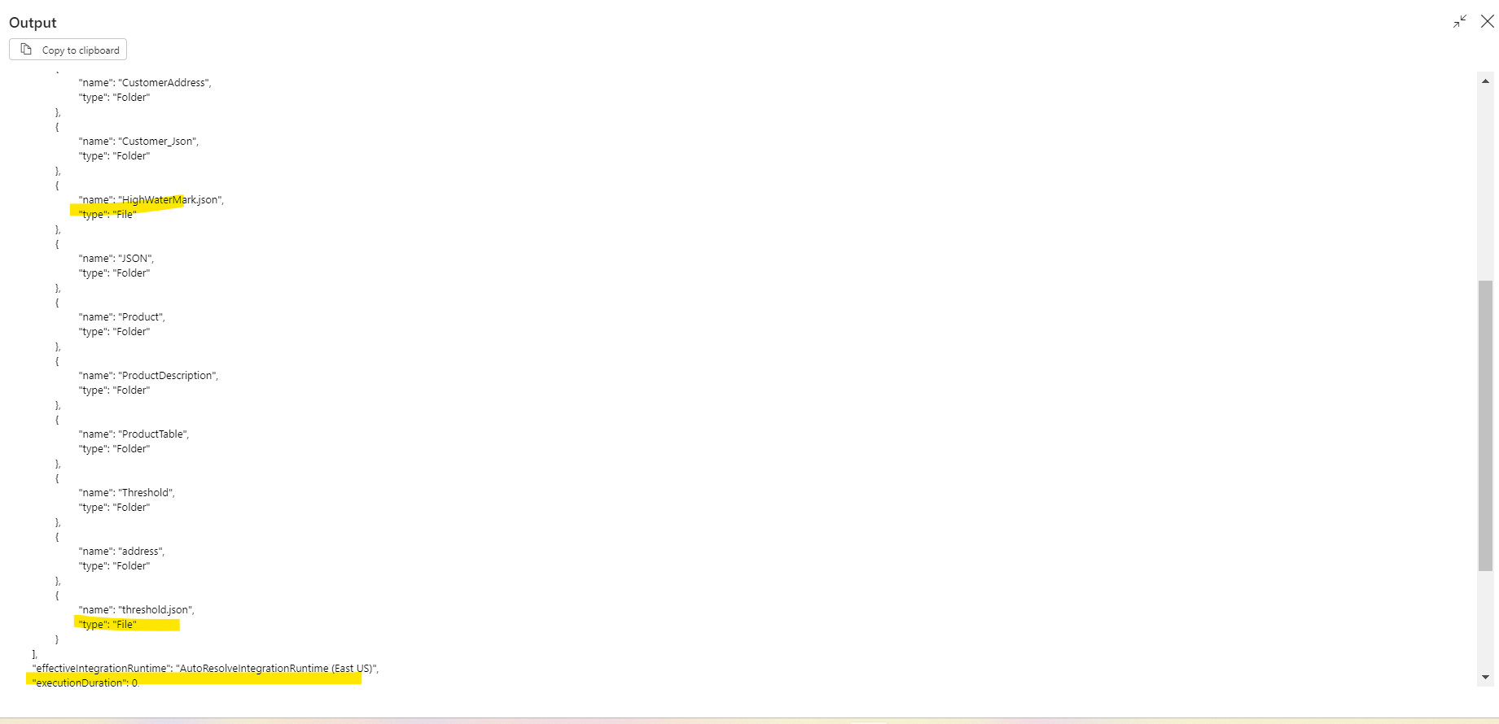

## Question 2. Create a pipeline name 'Foreach_Example' to copy the Customer & Customer address table data into ADLS using the one copy activity.

Solution:- Firstly create a for each activity then within for each create a copy activity.

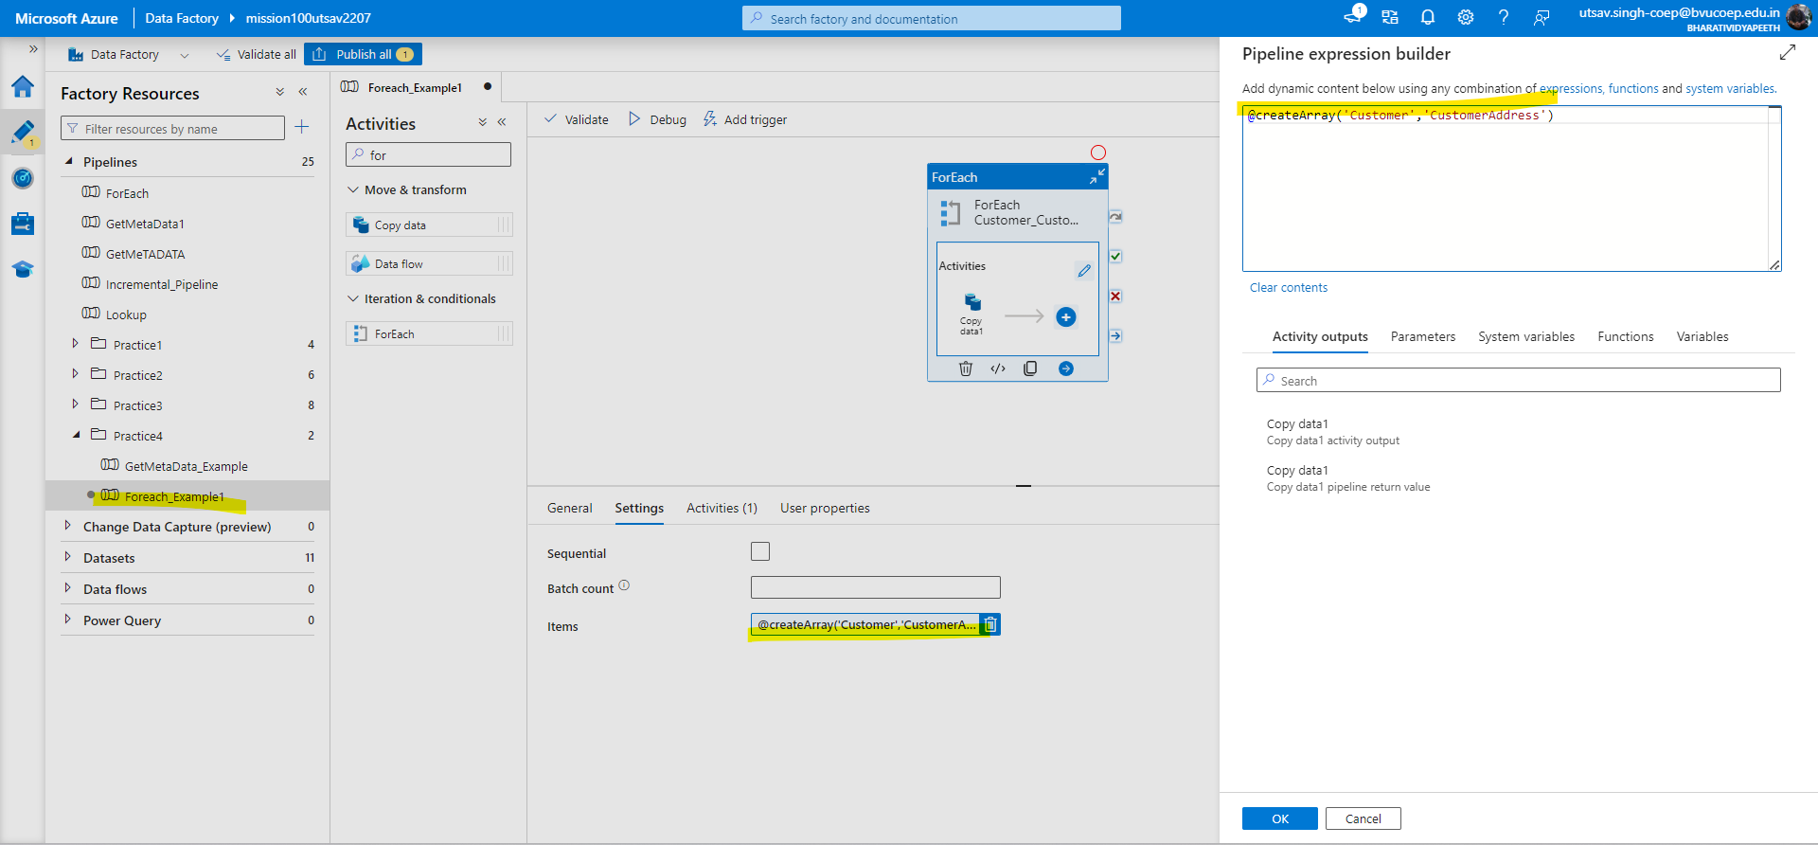

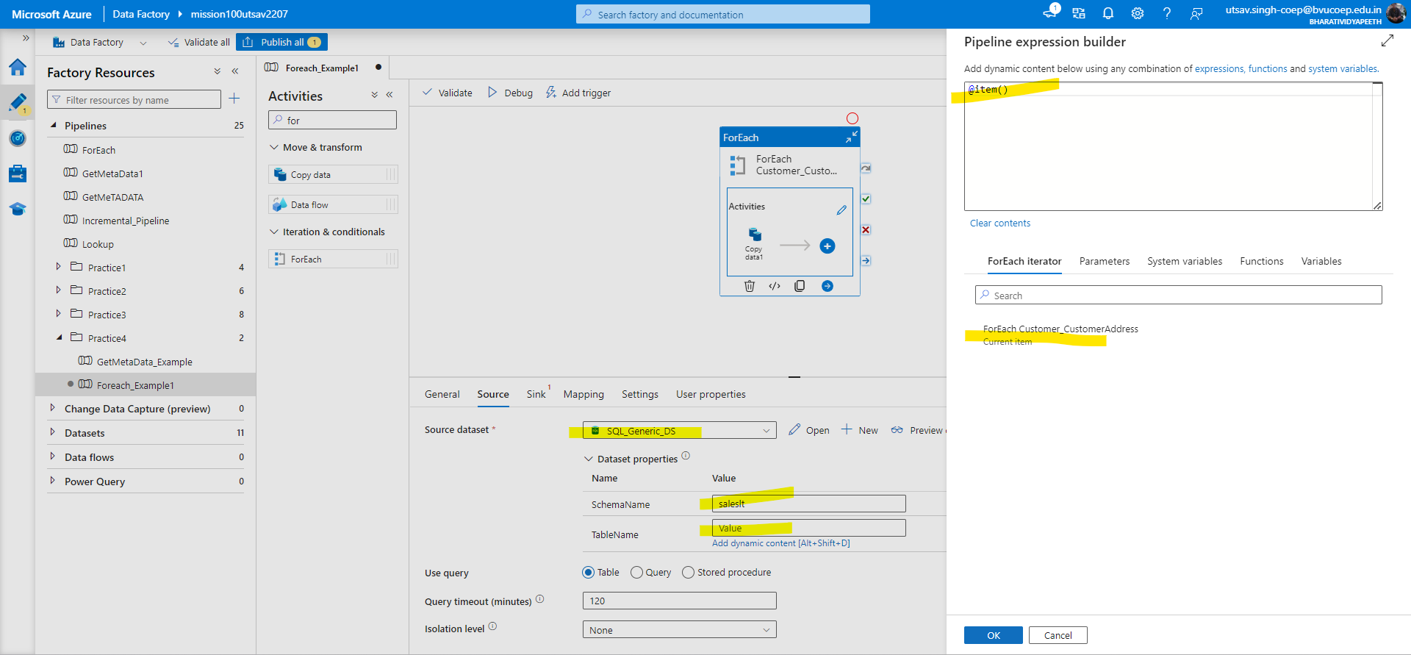

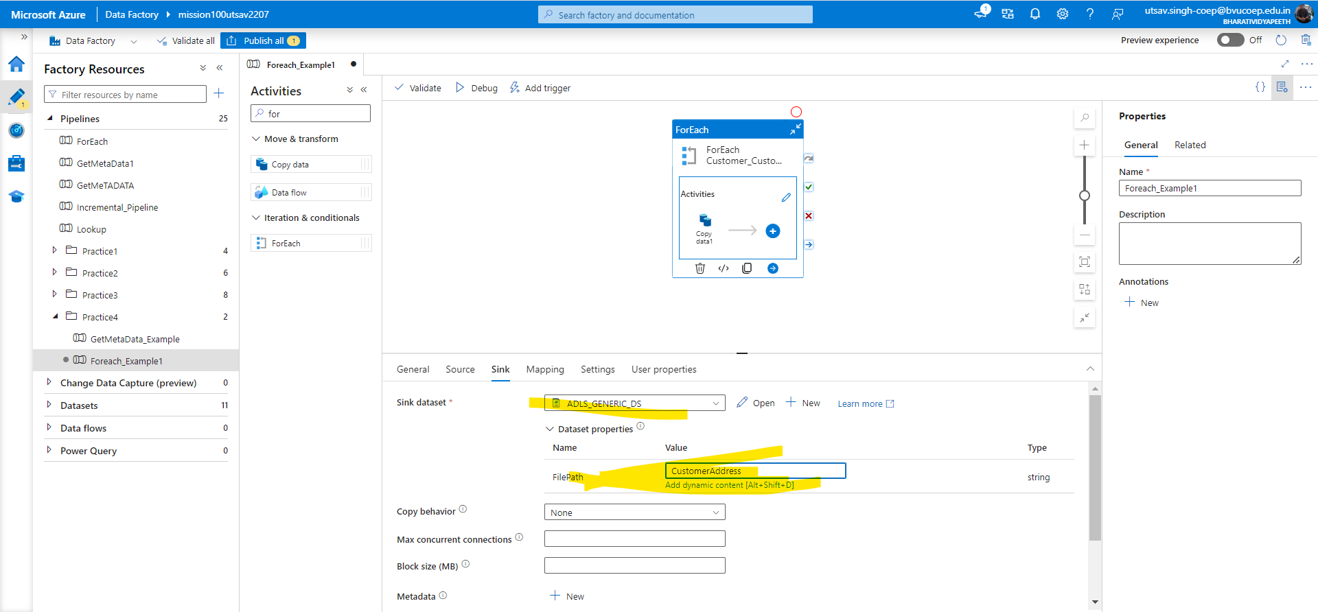

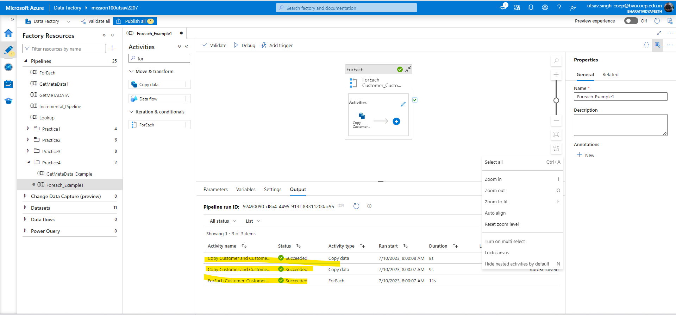

## Tough Questions:

## 

## Question 3. Create a pipeline that first checks whether the Customer.csv file is available in the folder location. If it is available it will copy the file data to the Customer Table.

Solution:-From the question itself it is asking for file existence so, we can create meta data activity. Then we can create dataset where file is present. Create if activity to check whether file is present or not and if present then copy the file data to Customer table using Azure sql dataset.

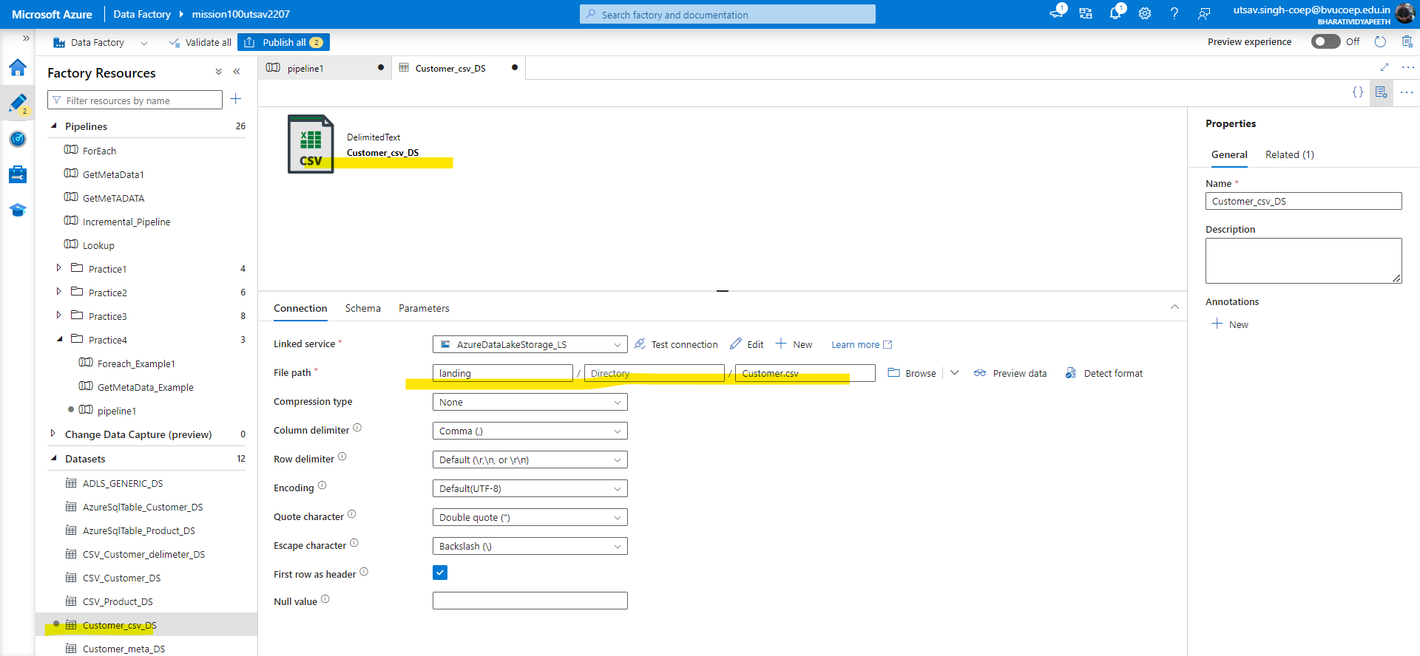

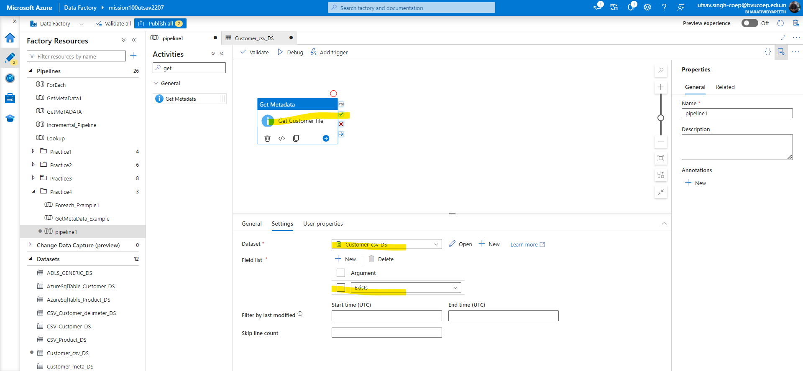

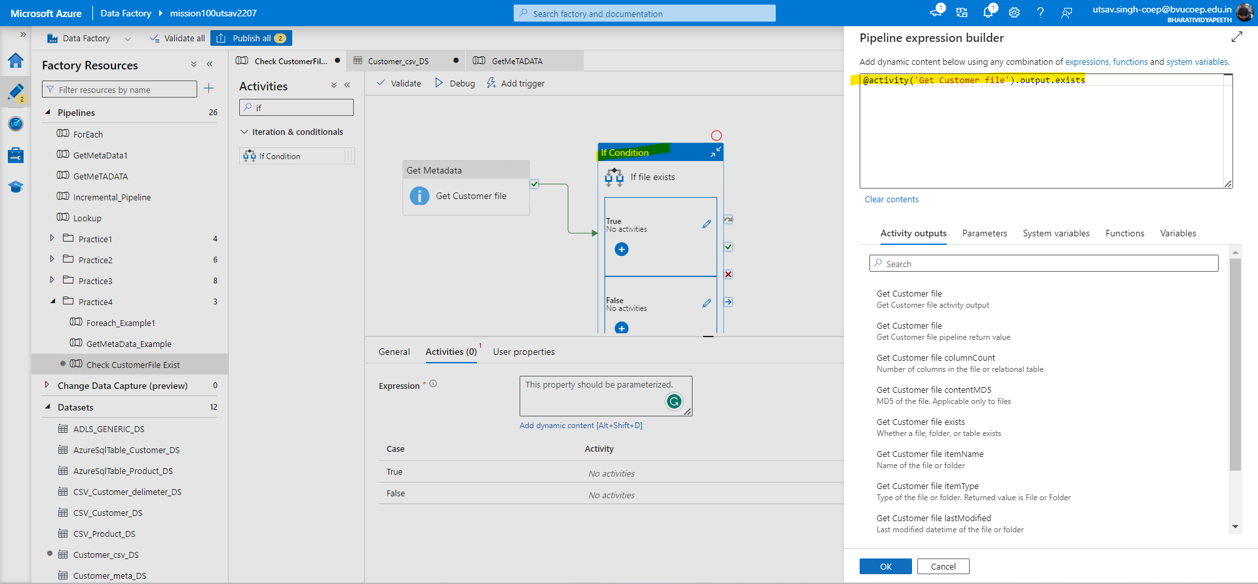

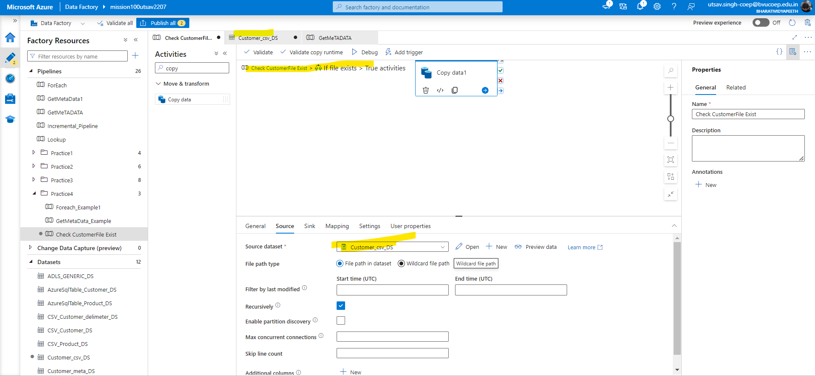

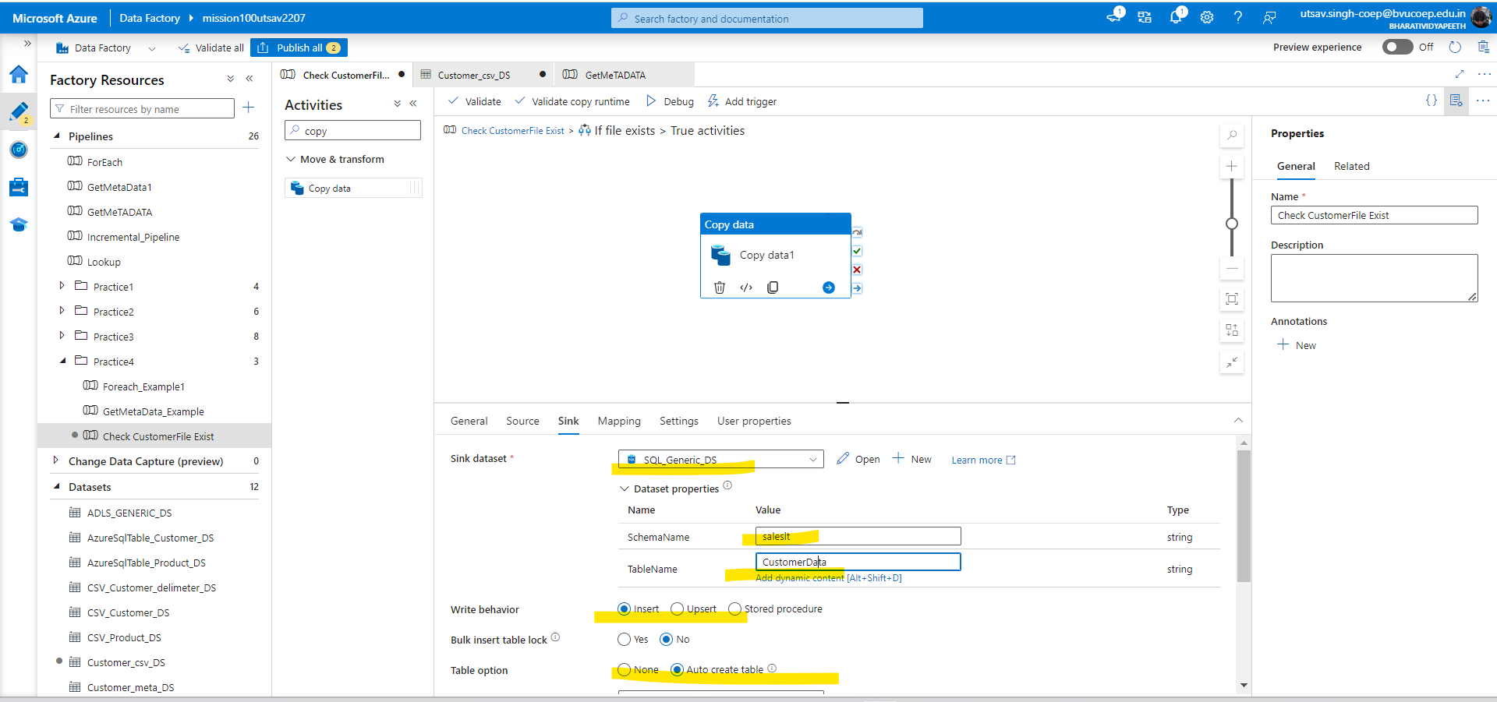

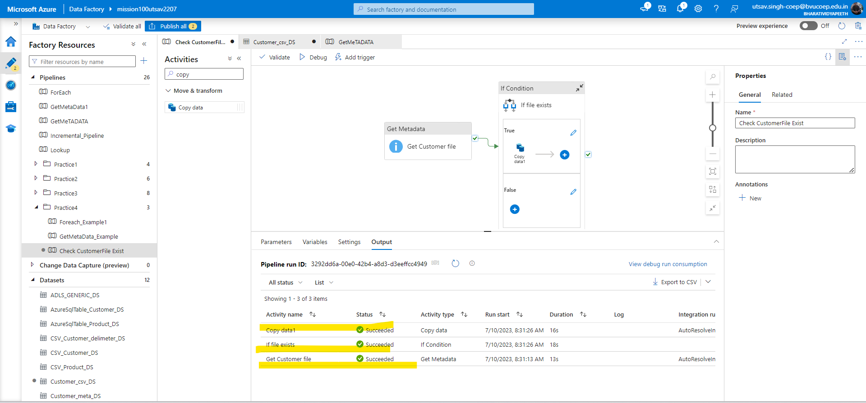

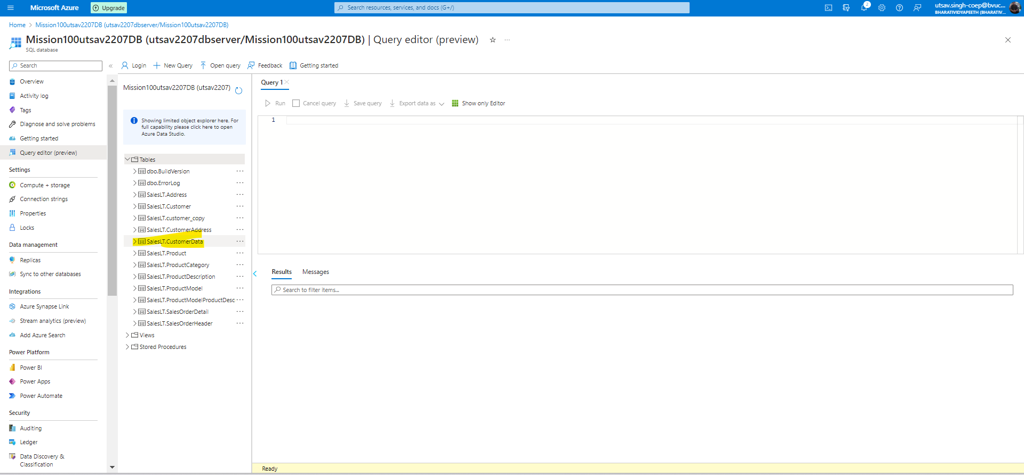

## 

## 4. Create a pipeline that will create the incremental pipeline using the table instead of HighWaterMark File.

Solution:- Firstly we have to create a table for Highwatermark and then create two lookup activity one to check Highwatermark date and 2nd to check lastmodified date from customer table. Now create copy activity and in query tab use dynamic content select * from saleslt.customer where modified date > ‘@{Hw_date}’ and modifieddate<=’@{max of customer}’.

Again create another copy activity to update the data.

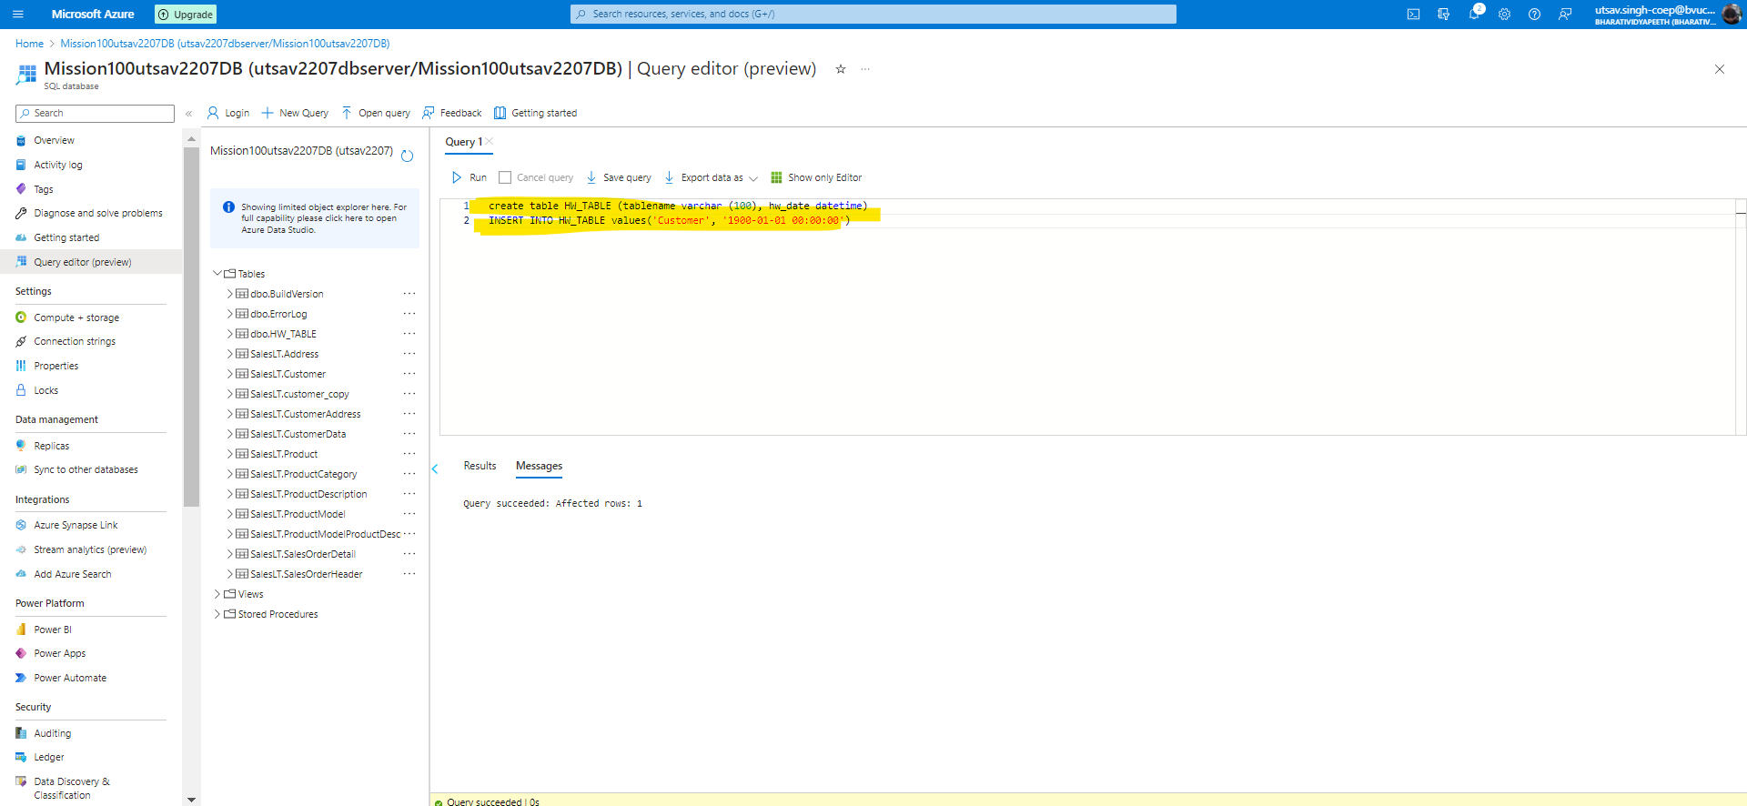

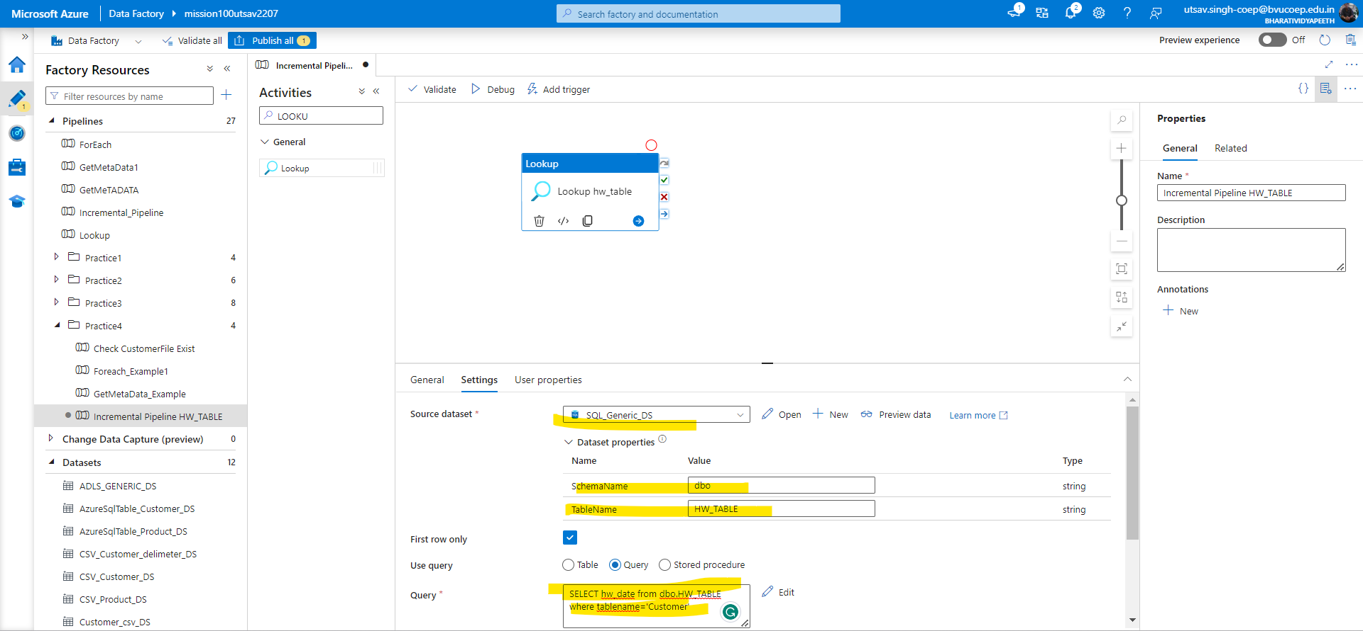

## 

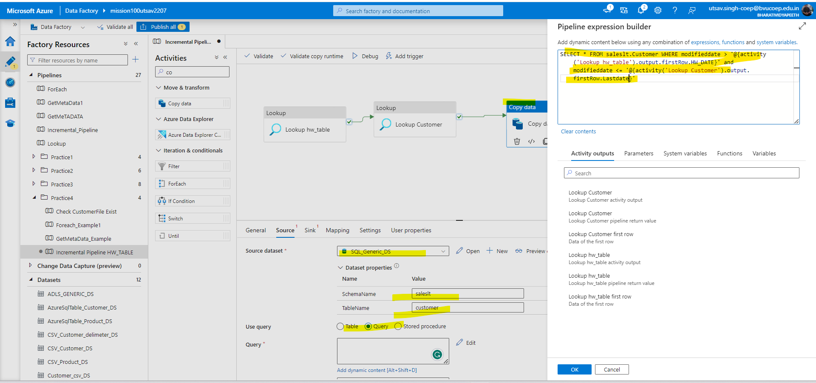

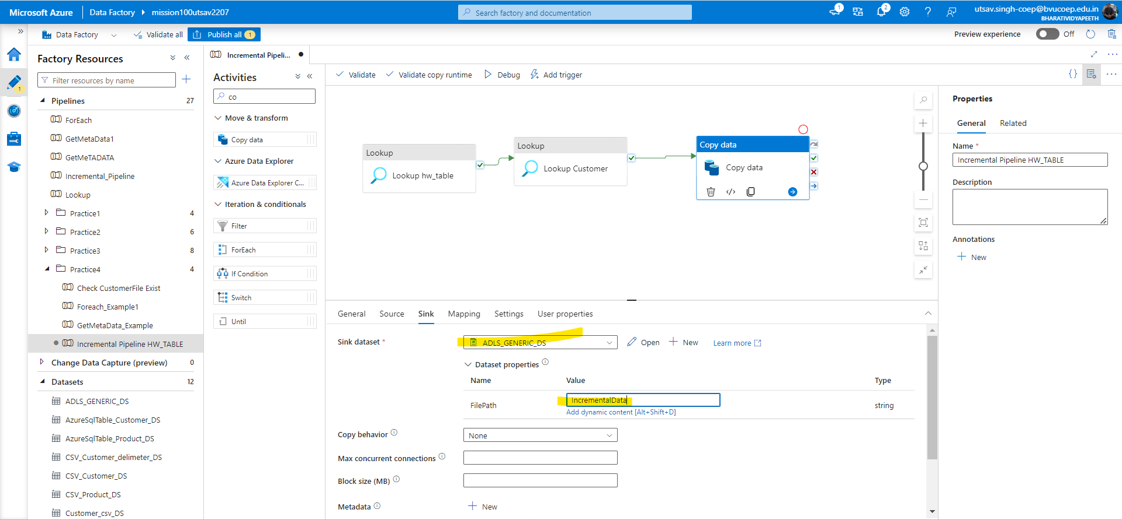

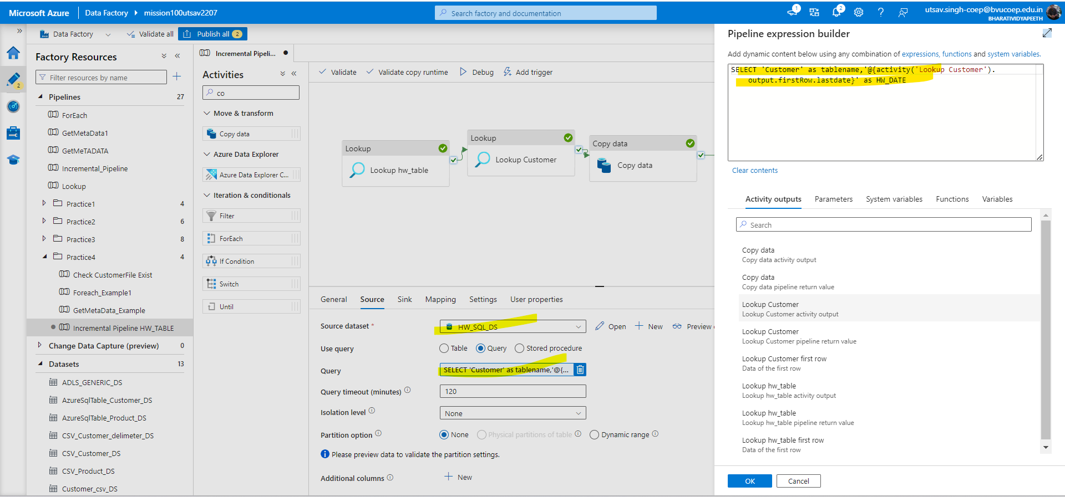

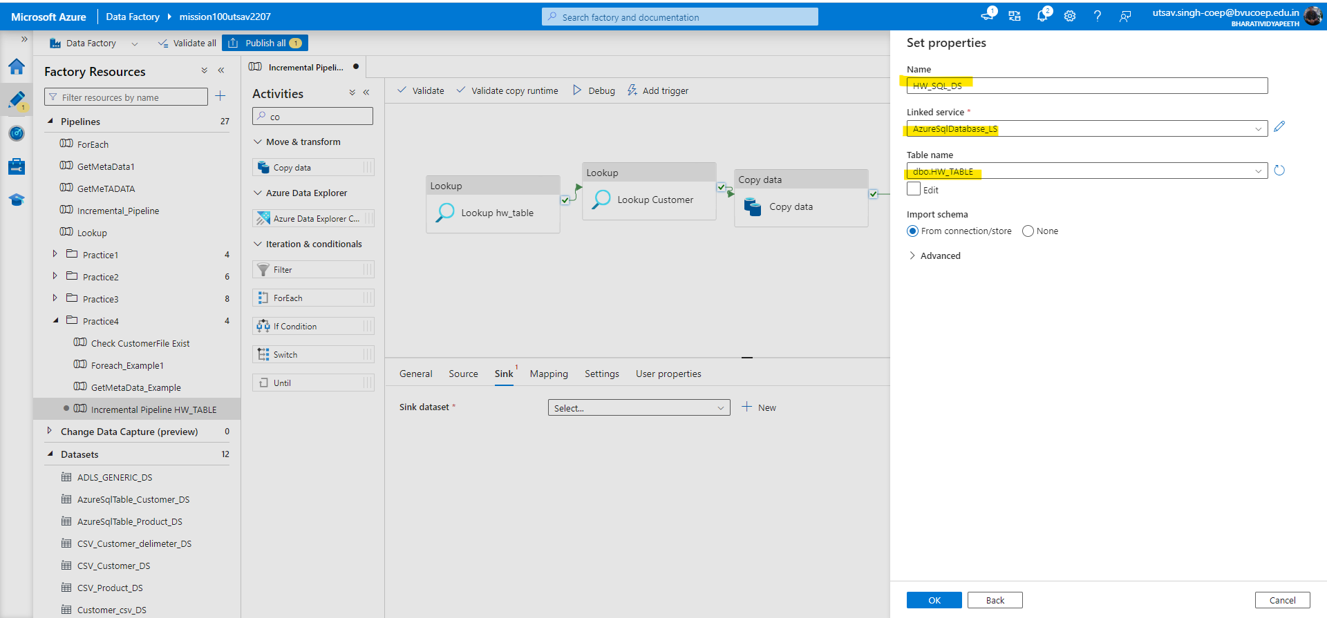

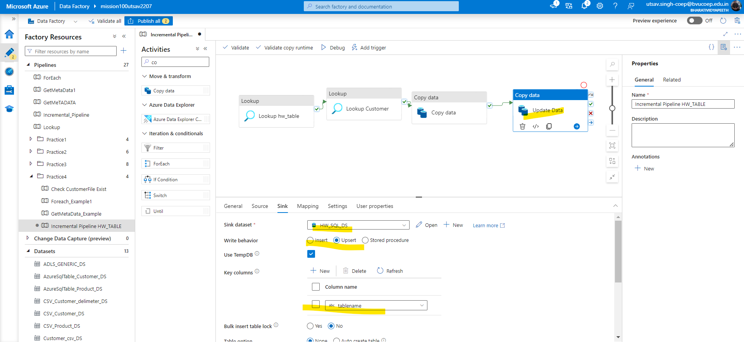

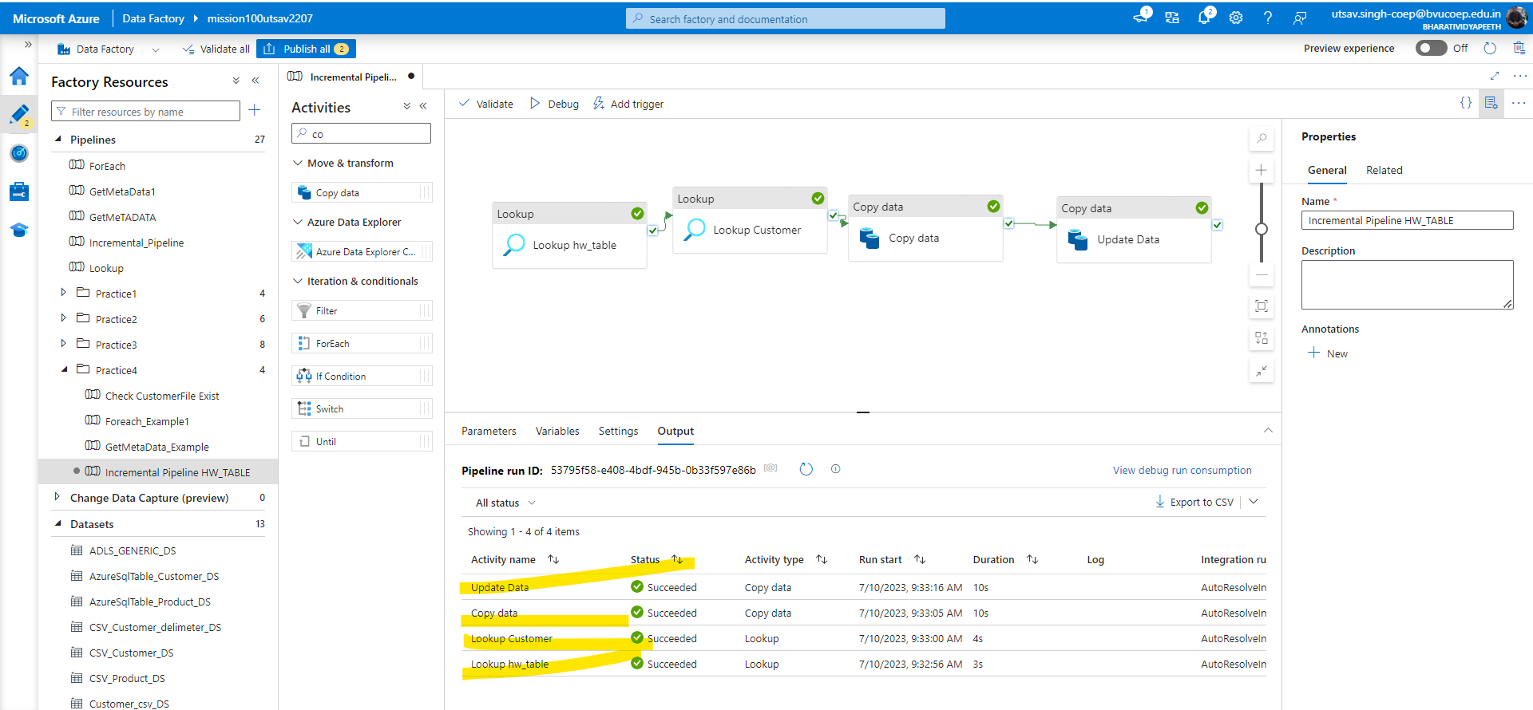

## 5. Create a pipeline name 'Foreach_Example2' to copy the below information using just one copy activity.

## 

## - All the product table data where productid > 100

## - All the customer table data where Customer id>100 and Customer id <1000

Solution:-For this we will firstly create for each activity and use create function and type dynamic query for the product and customer. Then use Copy activity to copy the data.

